The Hartt School Community Division
Betsy Cooper, Dean
Noah Blocker-Glynn, Director
presents

Performer Name or Concert/Show Title
with
Name of Assisting Performers/Accompanist

Monday, Jan. 1, 2018, 7:30 p.m.
Name of Concert Hall

Program Title Composer
Performer(s)

Program Title Composer
Performer(s)

Program Notes
Text Translation
Biographies
Etc.

The font is Gotham Book or Arial

CONCERT ETIQUETTE
Thank you for attending today’s performance. Out of respect for the performers and other audience members, please turn off cell phones and refrain from talking during the performance. Applause is customarily given at the conclusion of complete compositions, but not after individual movements. Also, please remember to enter the auditorium only during applause and
to leave only at the conclusion of the concert,
except in the case of an emergency.
Enjoy the concert!



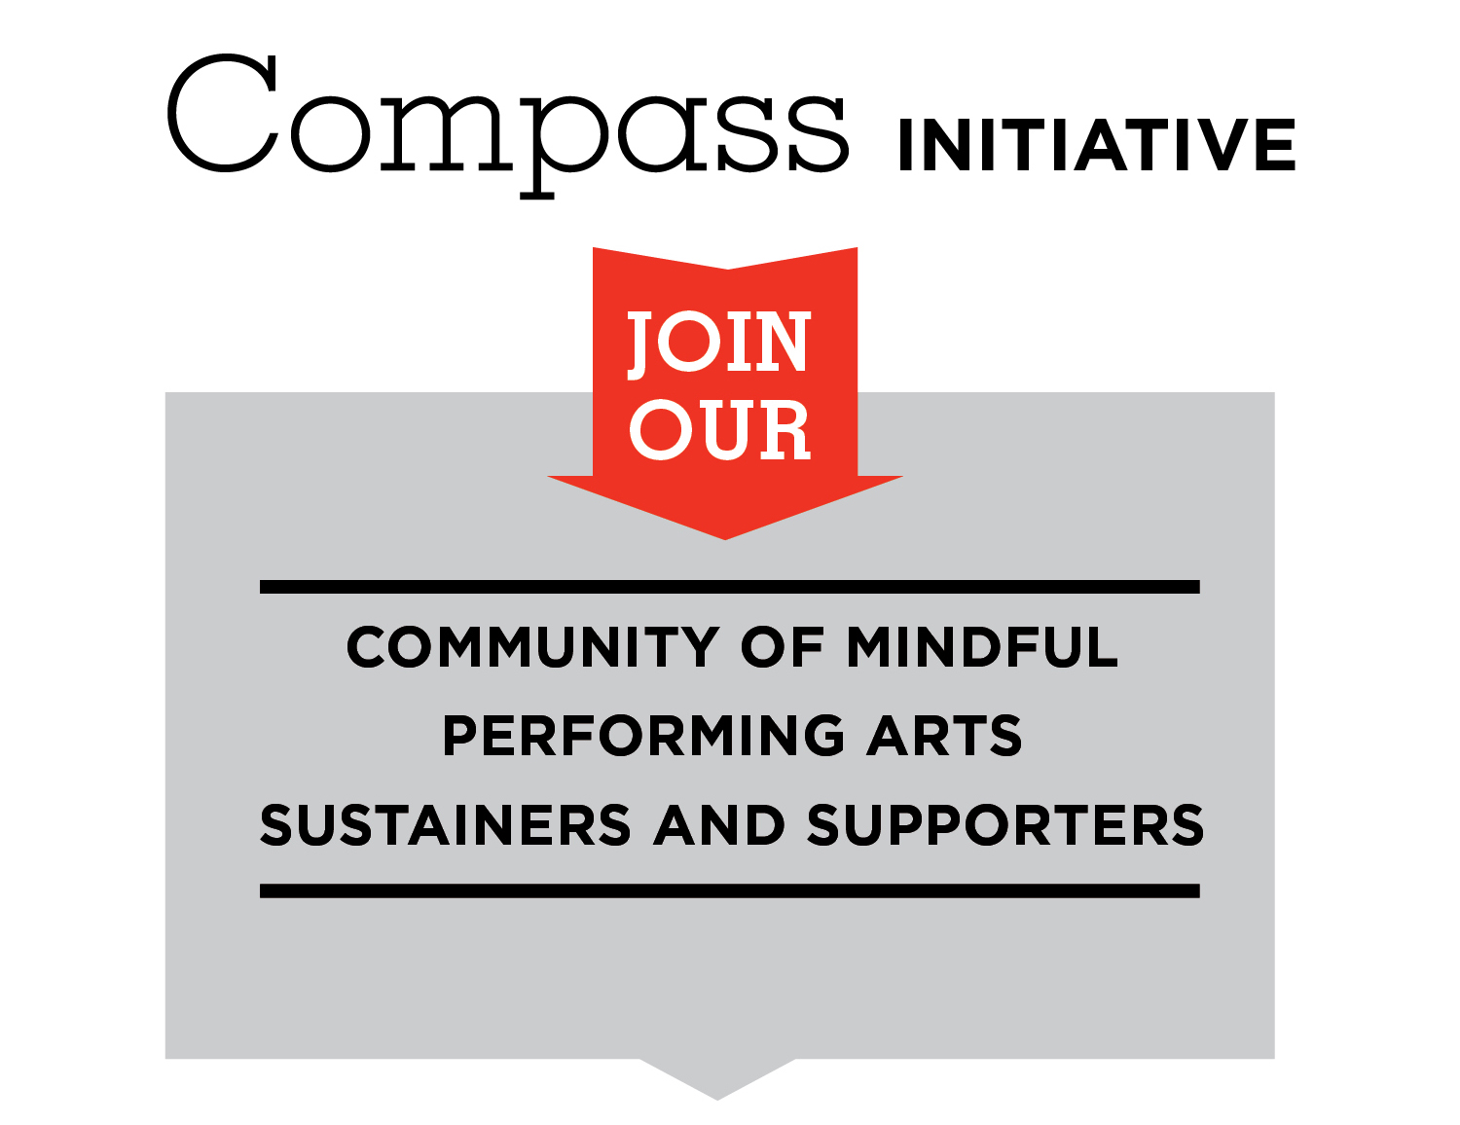
Every gift is a gift of magnitude.

Volunteer or make a financial contribution to
The Hartt School Community Division,
where we enrich lives through innovative and
unparalleled performing arts education.
Visit us online at hartford.edu/hcd/give.
Thank you.



